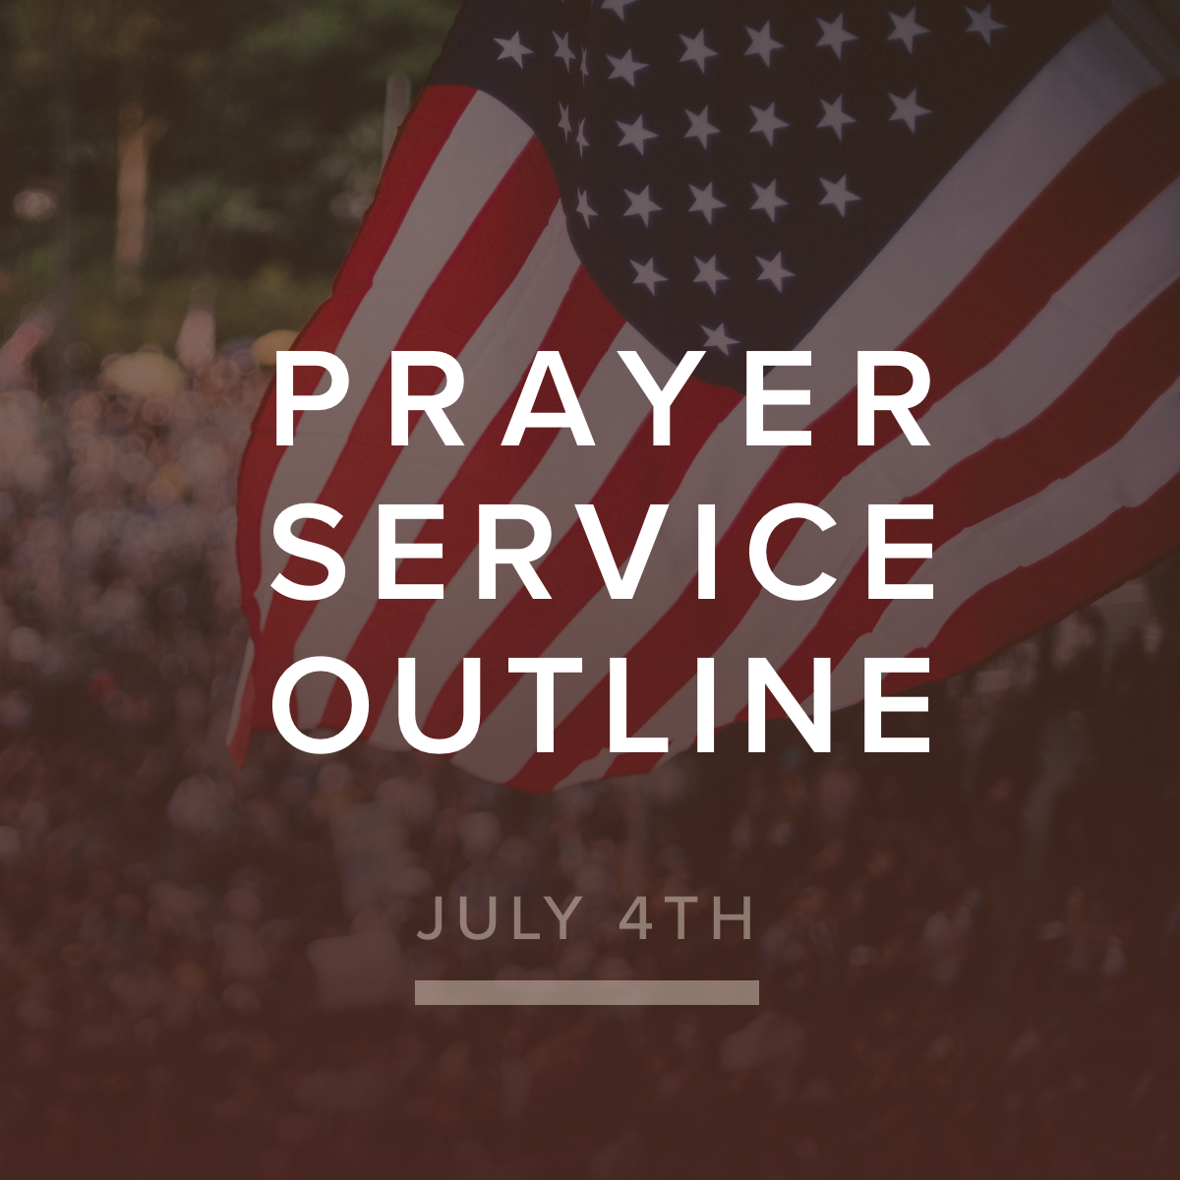

“if my people who are called by my name humble themselves, and pray
and seek my face and turn from their wicked ways, then I will hear from heaven
and will forgive their sin and heal their land.“
2 Chronicles 7:14 (ESV)

Order of Service

Opening song
Welcome – Explanation of service, key verse – 2 Chron. 7:14 distinguishing between Israel and the church - announcements – offering
Worship song

REVERENCE:

“if my people”
Praise for our identity in Christ as “his people"
Several readers come to mic and read selected truths (rotating back a forth) of our identity in Christ -- while coordinated with these truths appearing on the screen for visual affirmation.
SONG: Theme – Theme: Our identity in Christ
“who are called by my name”
Praise focus: Microphone open – people coming to mics declaring the NAME by which we have been called (Names of Father, Son, Holy Sprit) – prompt: “I praise You that Your name is…” Interspersed every 4-5 times with antiphonal affirmation – “We are called by Your name!”
SONG: Theme – The Glory or greatness of His name

RESPONSE:

“humble themselves”
Encourage all to take a posture that would reflect humility before our awesome God (bowing, kneeling, prostrate, etc) – Silent prayers for 2-3 minutes
PROMPT:
“Lord, I confess I need humility in…”
Song: Theme - humility
REQUESTS:

“and pray and seek my face and turn from their wicked ways”
(Commentary: Turning from our wicked ways is the natural expression for those who seek His face)
PROMPT: (perhaps in groups for those who are comfortable)
“Because You are _______________________ (characteristics of His “face”/character) I ask for grace to turn away from __________________.” (focus on personal response – corporate will come in the next segment)
Transition prayer by a leader (from mic) – prayer for the nation, our leaders, government, etc.
SONG: Theme: repentance/confession

READINESS:

“then I will hear from heaven and will forgive their sin and heal their land.”
PROMPT (using open mics again):
One after another – “Lord forgive US for…”
Antiphonal response: “Heal us, O Lord!”
Closing prayer of faith and expectation by a church leader
Final song of worship.

